Table 1: Public Consultation Workshops for PEACEPLUS
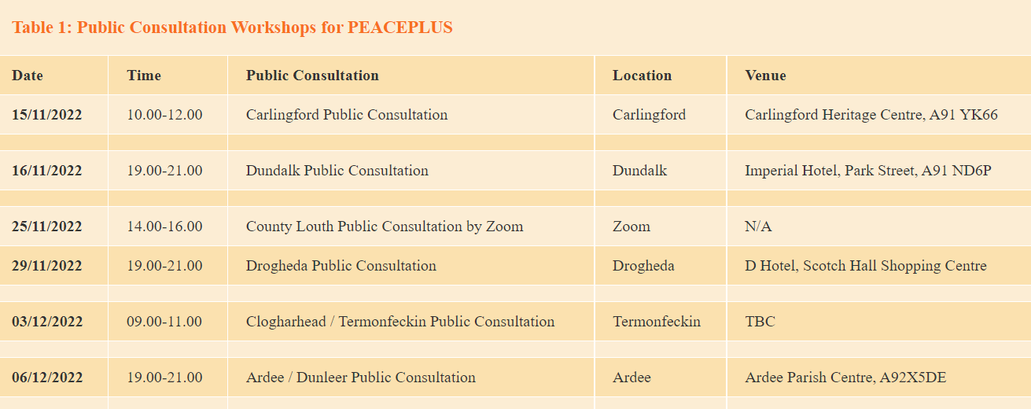

Thematic Groups below:

Table 2: Thematic Focus Groups for Peace Plus
